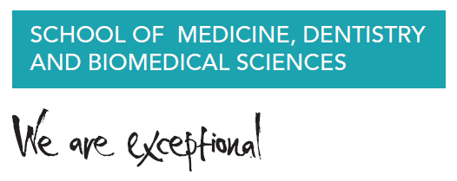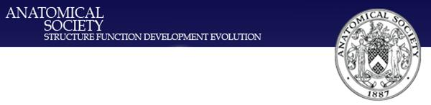

**Centre for Biomedical Sciences Education**

**Seminar**

**Monday 16th May 2016 (2-5PM)**

**MBC/G07NT**

**Augmented Anatomy:**

**The wide-ranging benefits of a dissection-based anatomy course**

*2016 marks the 300th anniversary of the establishment of the Anatomy School in Cambridge, with dissection-based instruction starting even earlier in the Colleges in the 1560s. This seminar will focus on how this well-tested approach allows medical students, as Tomorrow’s Doctors, as well as biomedical and human biology students to develop in multiple domains: knowledge and intellectual ability, personal transferable skills, clinical understanding and professionalism, as well as motivating them to have inquiring scientific minds.*

Dr Cecilia Brassett