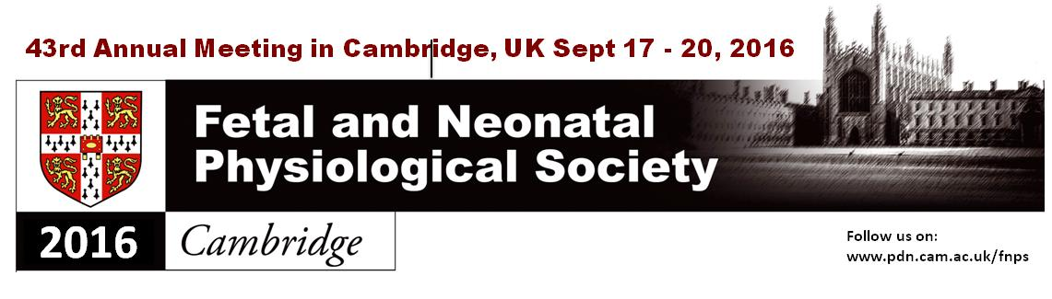
Abstract Submission
Instructions for authors
Please write your abstract using the 1-page abstract template provided on the following page. Font type and size as well as any formatting should be maintained. Otherwise, your abstract will be rejected and you will be asked to resubmit it.
We encourage you to include a Figure or Table in the space provided.
The word limit for the body of the abstract is 350 words and the entire abstract must fit on one page within the delineated border.

Specifics
Title: Arial font, 12pt, white text on black background, sentence case, centred, one or two lines.
Authors: Surname, A. B., Arial font, 11pt, bold, presenting author underlined.
Affiliation: Arial font, 11 pt, italics.
Body of abstract: Arial font, 11pt, justified, including headings for Introduction, Methods, Results and Conclusion. Word limit for the body of the abstract is 350 words.
Table/Figure: centred. Legend in Arial font, 11pt, justified.

Submission
- Please email your completed abstract as a Word Doc to Dr. Kim Botting at kb555@cam.ac.uk

- Indicate if you would prefer a talk or a poster.

- In your email please also include if you are a PhD student or a Post-Doc to be eligible for relevant Prizes.

Deadline
The deadline for abstract submission is June 30th 2016. The meeting is likely to be very well attended and abstracts will be allocated on a competitive as well as timely basis.

Title (Arial font, 12pt, white text on black background, sentence case, centred, one or two lines)
Surname, A. B., Surname, C.D. & Surname, E.F.

Affiliation (Arial font, 11 pt, italics)

Introduction: (Body of abstract in Arial font, 11pt, justified, word limit 350 words)
In the early 1800s, eccentric poet Lord Byron is reported to have kept a bear while he was a student at Trinity College. He is said to have purchased the bear, quite possibly at Stourbridge Fair, in defiance of the rules that banned students from keeping dogs in college. On 26 October 1807 Byron wrote to his friend Elizabeth Pigot: “I have got a new friend, the finest in the world, a tame bear. When I brought him here, they asked me what to do with him, and my reply was, ‘he should sit for a fellowship’.”
Methods: Individuals associated with Cambridge University have won 89 Nobel Prizes in all six disciplines covering physics, chemistry, peace, literature, physiology and medicine. Cambridge also claims the most Nobel Prizes in physics with 29 in total. The University’s total prize count is well above Oxford University at 58, although Oxford has produced the most Prime Ministers.
Results: Night climbing is a frowned-upon activity of the students that involves climbing on the college buildings at night. Some of the climbers, not just content with scaling the centuries-old structures, have used night climbing to commit several inventive pranks. In 1958, Cambridge engineering students from Gonville & Caius College put an Austin Seven car on the roof of Senate House. It took the University a week to remove it. In 2009, students placed some 25 Santa hats on various buildings, including the pinnacle of King’s College Chapel and the top of Pembroke’s Porter’s Lodge.
Conclusions: The first official game of football/soccer with rules we would recognise today was played on Parker’s Piece, the big public park in the middle of Cambridge. It was played in 1848 between the City and the University. City won 2-1 with a late goal.

Table or figure with legend (Table/Figure centred. Legend in Arial font, 11pt, justified)
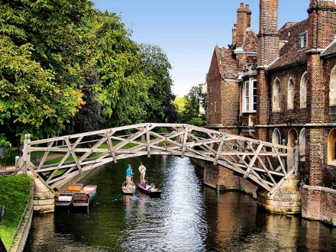
Figure 1. The Mathematical Bridge. According to legend, much favoured by Cambridge tour guides, the Mathematical Bridge was built by Newton from nothing else but wood. No nuts, no bolts, just what wood can make and bear. The legend says that Sir Isaac Newton built the bridge to illustrate the principles and properties of force and gravity. However, most remarkably, Sir Isaac Newton died 22 years before its construction.

