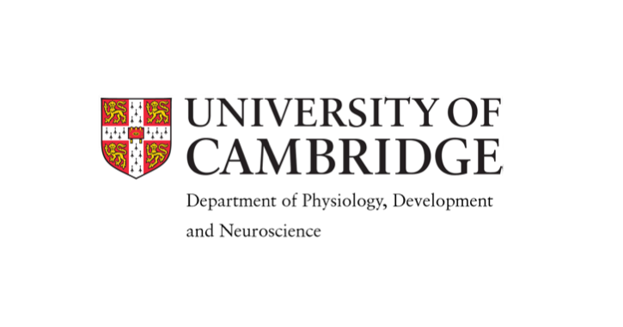
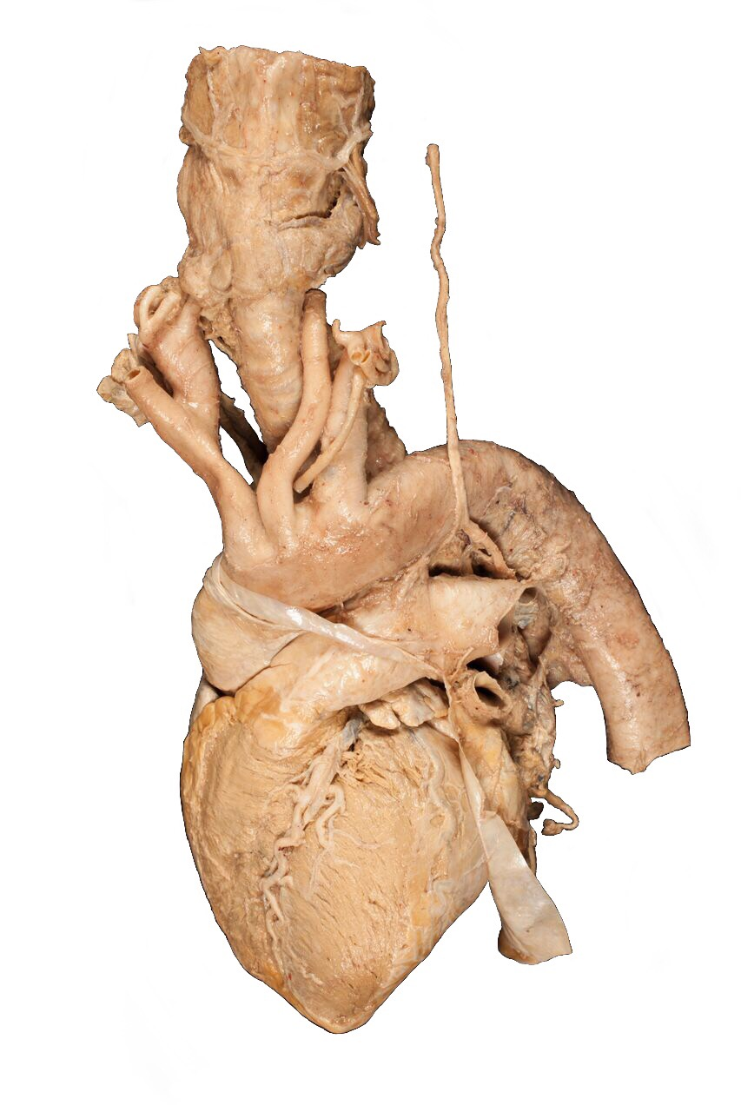

Cardiothoracic Anatomy Course

One day intensive course covering cardiac and thoracic anatomy to the standard expected of cardiothoracic trainees

Date: 16TH December 2017
Price: £60

Features:
- Small group teaching using cadaveric prosections and state of the art 3d virtual dissection software
- Taught by senior consultant cardiothoracic surgeons and registrars
- Keynote lecture by Mr Frank Wells, cardiothoraicic surgeon, The Royal Papworth Hospital
- To include radiology covering normal and pathological features taught by consultant cardiothoracic Radiologist
- Lunch & refreshments included
To register, please visit:
http://onlinesales.admin.cam.ac.uk/conferences-and-events/physiology-development-and-neuroscience/cardiothoracic-anatomy-course/cardiothoracic-anatomy-course-16-december-2017

For more information, please email cambridgectsanatomy@gmail.com. or visit https://www.pdn.cam.ac.uk/research/groups/human-anatomy-teaching-group/external-courses/CourseTimetable
Spaces limited

